UNIVERSITY OF ENGINEERING AND TECHNOLOGY
PESHAWAR, PAKISTAN
Main Campus
DATA STRUCTURES
Lab 01 Assignment
Submitted By
Name: ANAS KHAN
Registration No: Bf25pwcs1691
Semester: 2nd Semester, BS Computer Science
Section: B
Submission Date: 14-09-2026
Submitted To: Sir Mudasir
DEPARTMENT OF COMPUTER SCIENCE
UNIVERSITY OF ENGINEERING AND TECHNOLOGY, PESHAWAR, PAKISTAN

Lab Exercises 1.1
Task 1:
Modify the program to print your name, roll number, and course.

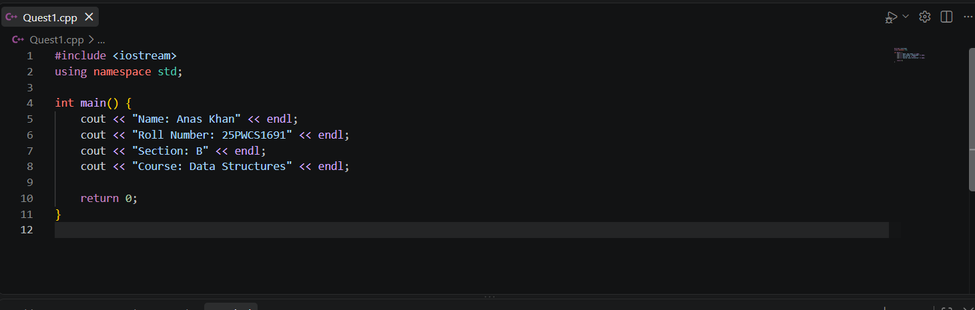
Program:

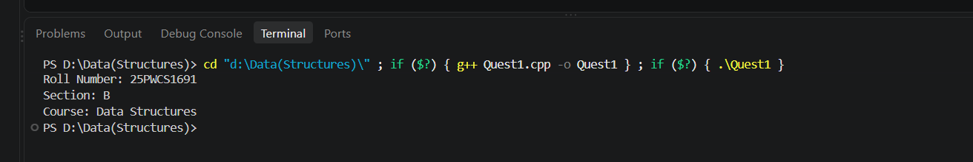
Output:

2- Introduce a deliberate syntax error (remove a semicolon) and observe the compiler error message.
Program:
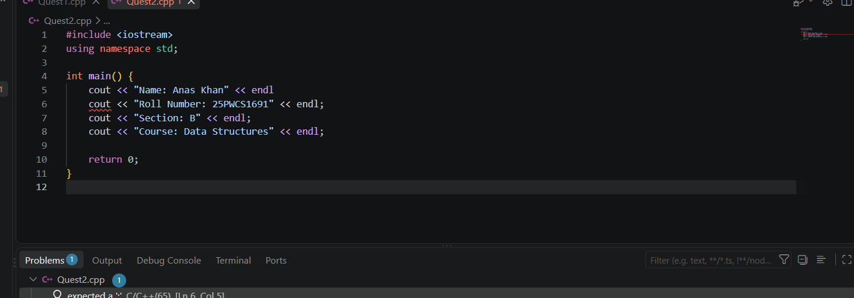

Output:

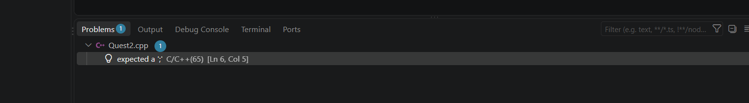

Lab Exercises 1.2
Task 1:
Write a program to take a student's marks in 3 subjects and print total and average.
Program:
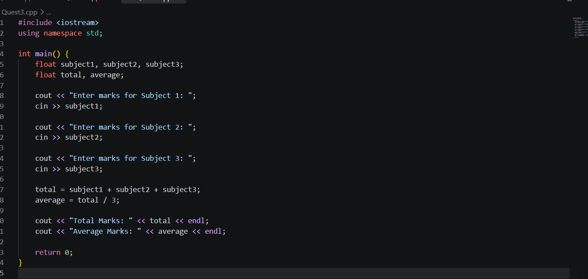

Output:

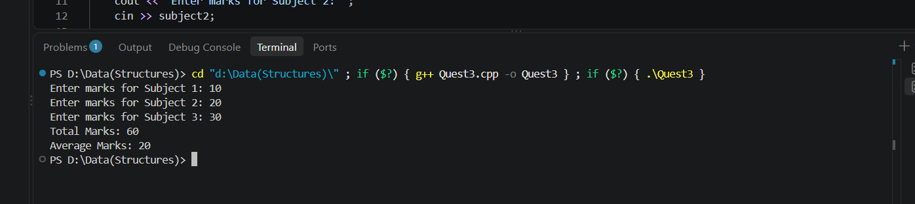

Task 2 :
Explore what happens when you assign a float value to an int variable (type narrowing).
Program:
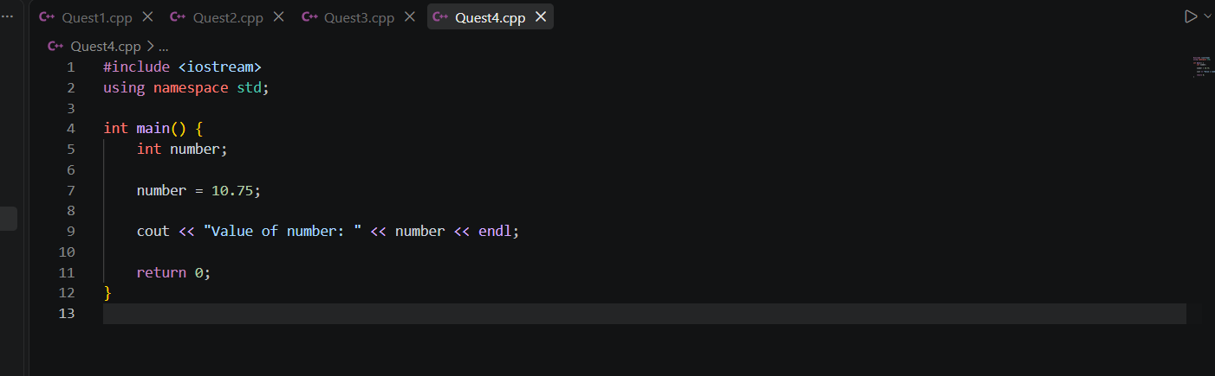
Output:
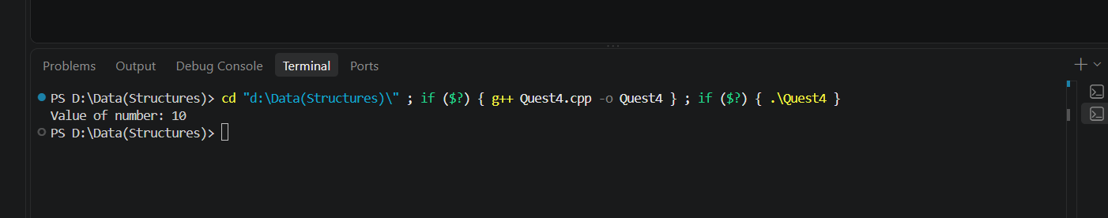
10.75 is converted to 10. The .75 is lost because an int can store only whole numbers.

Task 3 :
Use const to declare a constant and try modifying it — observe the compiler error.
Program:
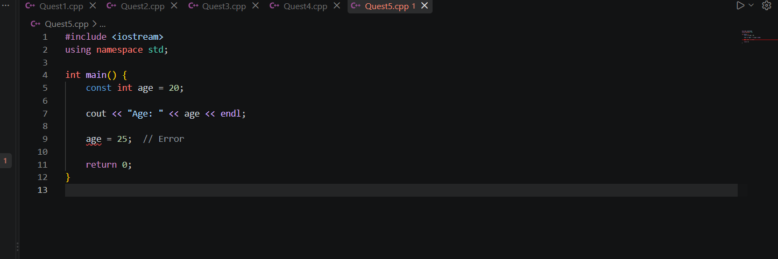
Output:
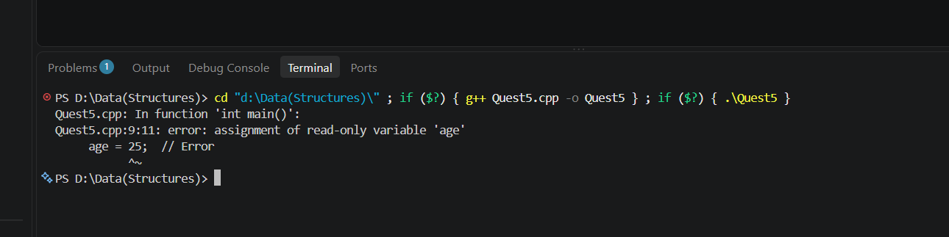
Because age was declared using const, its value cannot be modified.

Lab Exercises 1.3
Task 1:
Write a program to swap two numbers without using a third variable.
Program:
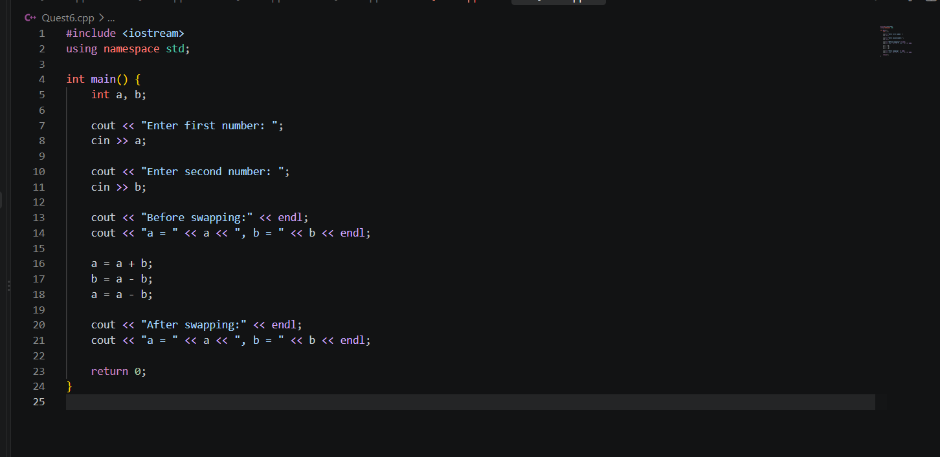

Output:
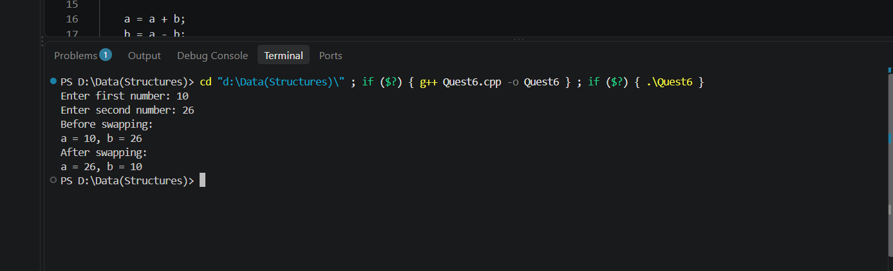

Task 2:
Write a program that checks whether a number is even or odd using the modulus operator.
Program:
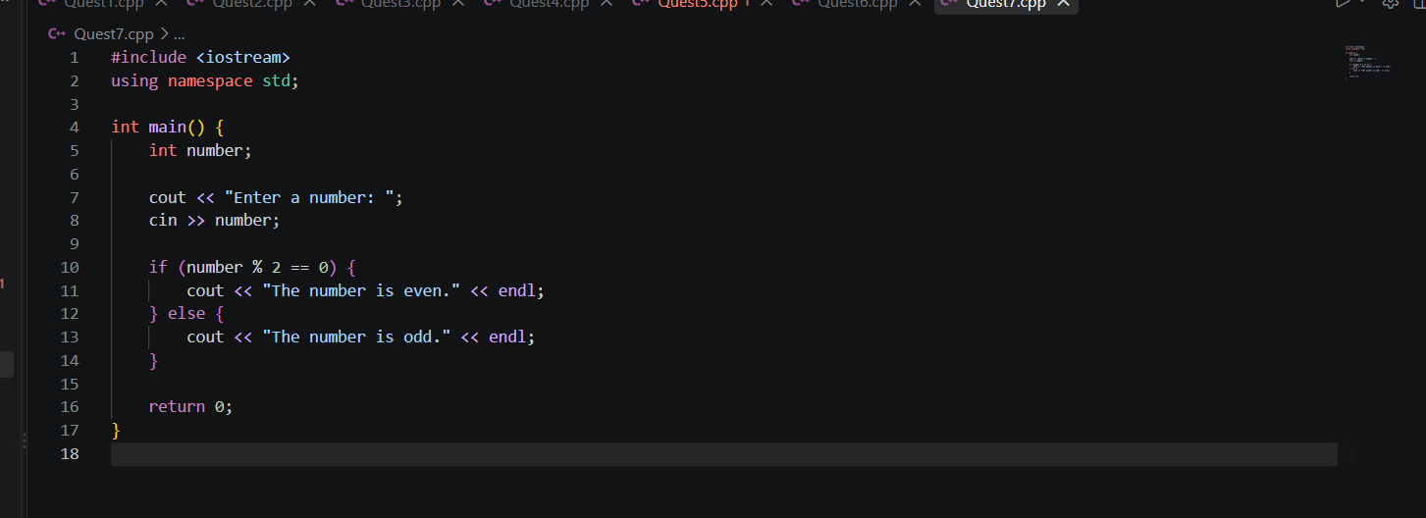
Output:
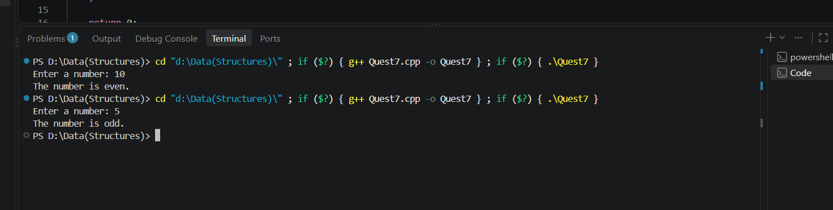

Task 3:
Predict and verify the output of int y = 5; cout << y++ + ++y;
Program:
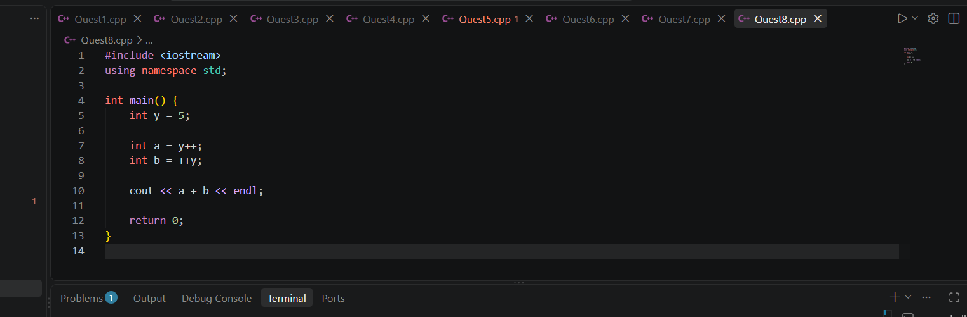

Output:
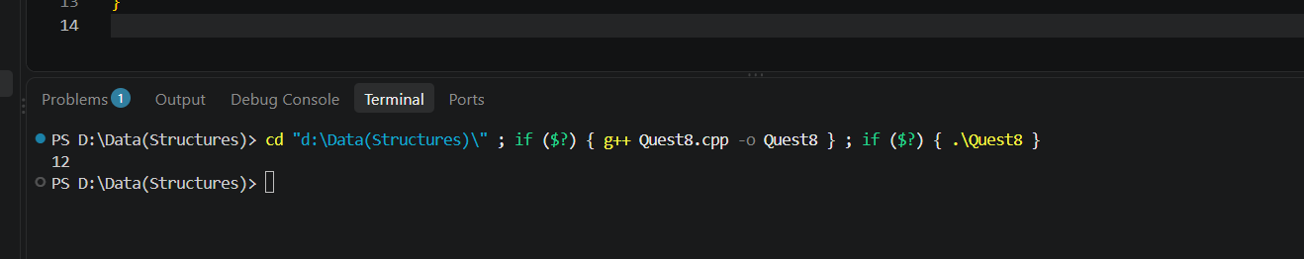
Lab Exercises 1.4
Task 1:
Write a program to check if a year is a leap year.

Program:
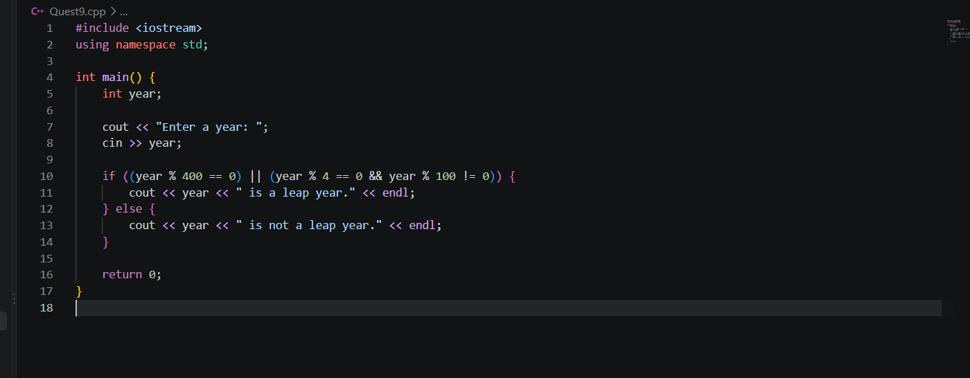
Output:
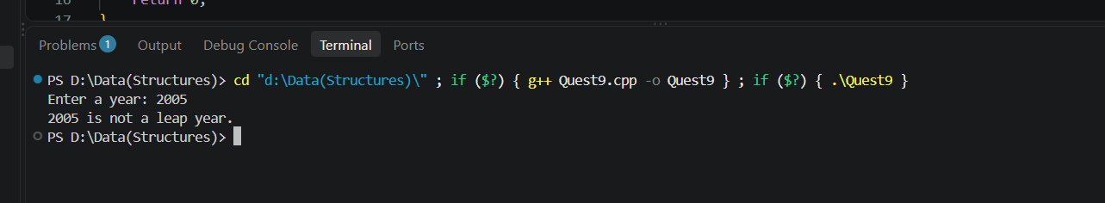
Task 2:
Build a simple traffic light simulator using switch (Red/Yellow/Green → message).
Program:
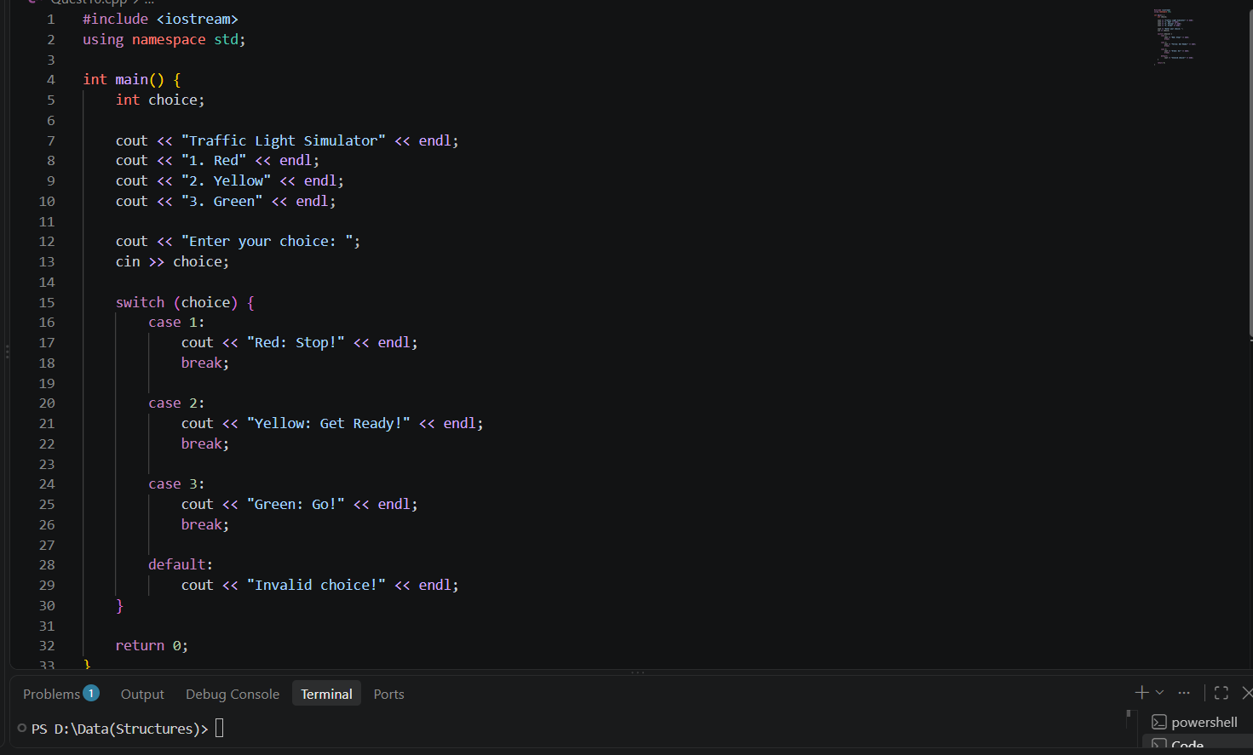
Output:
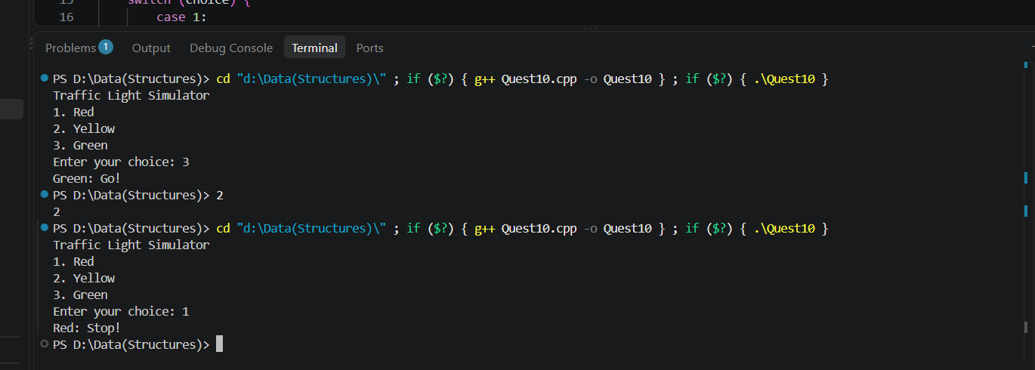
Task 3:
Rewrite Step 1's grade calculator using nested ternary operators.
Program:
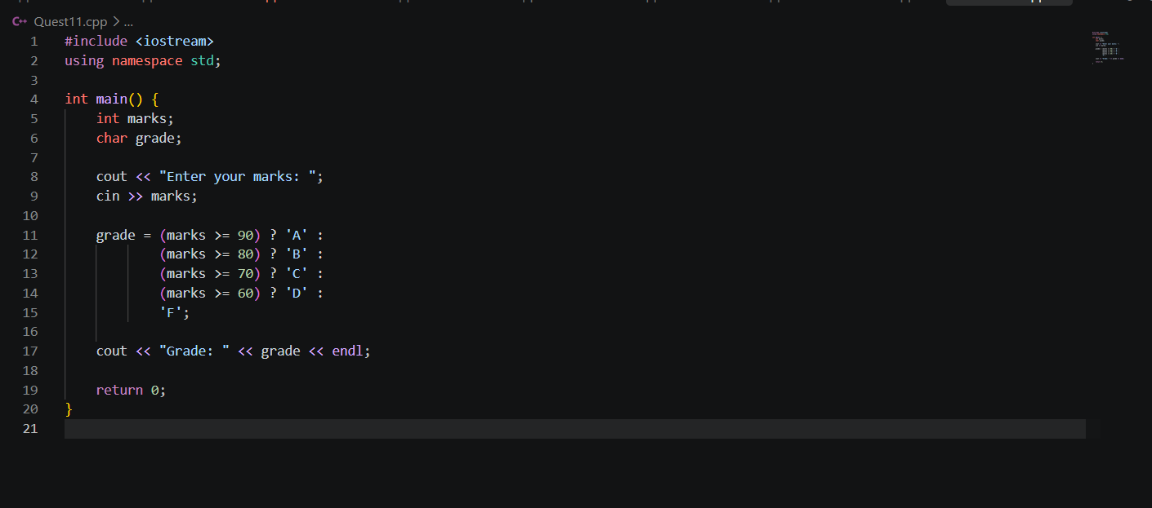
Output:
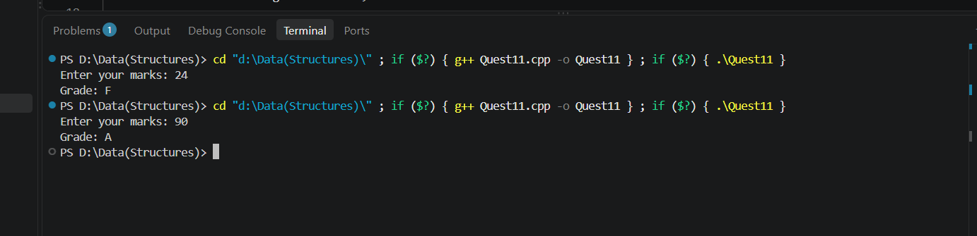

Lab Exercises 1.5
Task 1:
Print a right-angled triangle pattern of stars using nested loops.

Program:

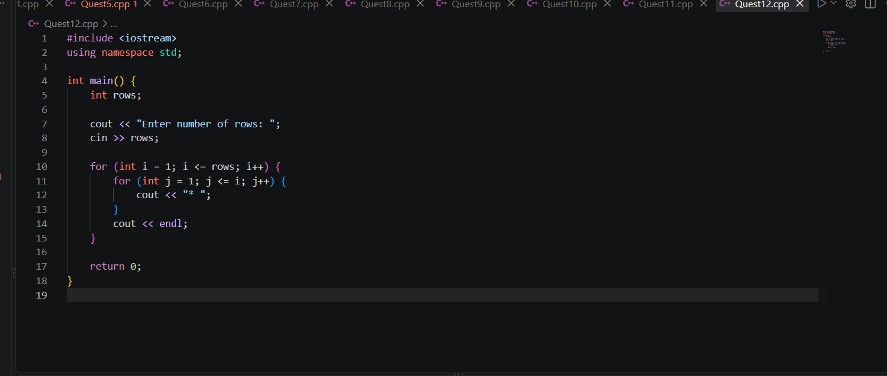
Output:
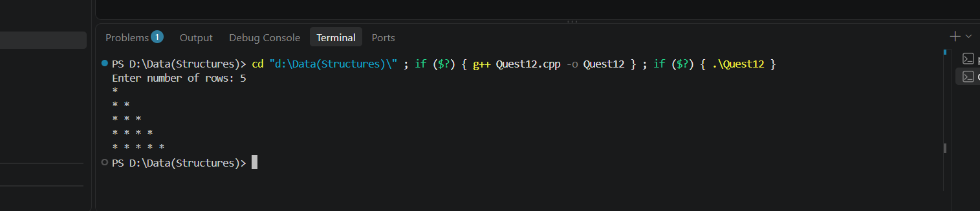

Task 2:
Check whether a number is prime using a for loop and break.
Program:
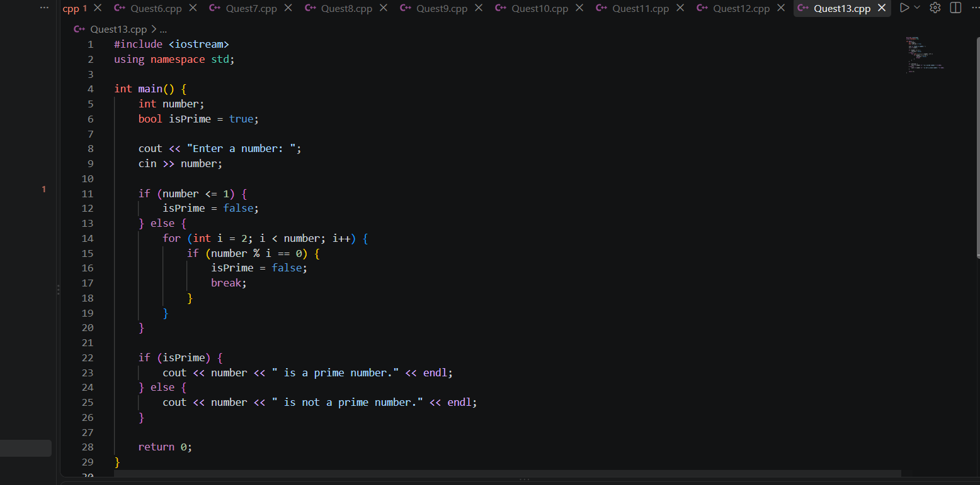
Output:
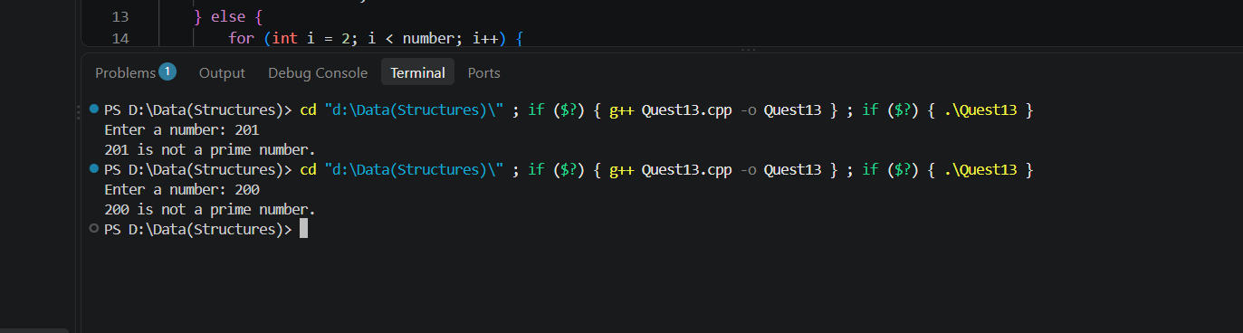
Task 3:
Print only even numbers from 1–50, skipping odd numbers using continue.

Program:
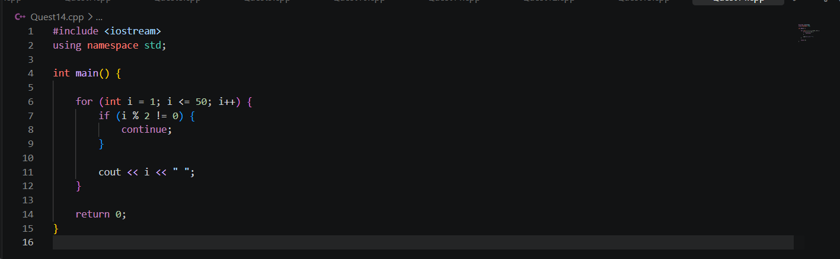
Output:
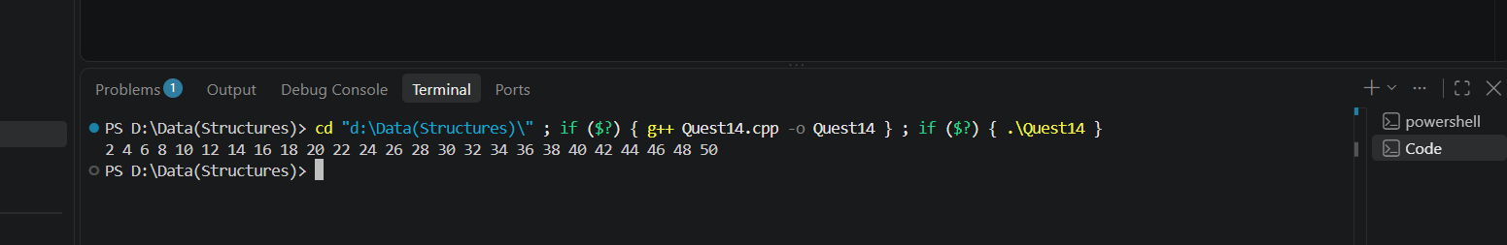
Task 4:
Reverse a number using a loop (e.g., 1234 → 4321).
Program:
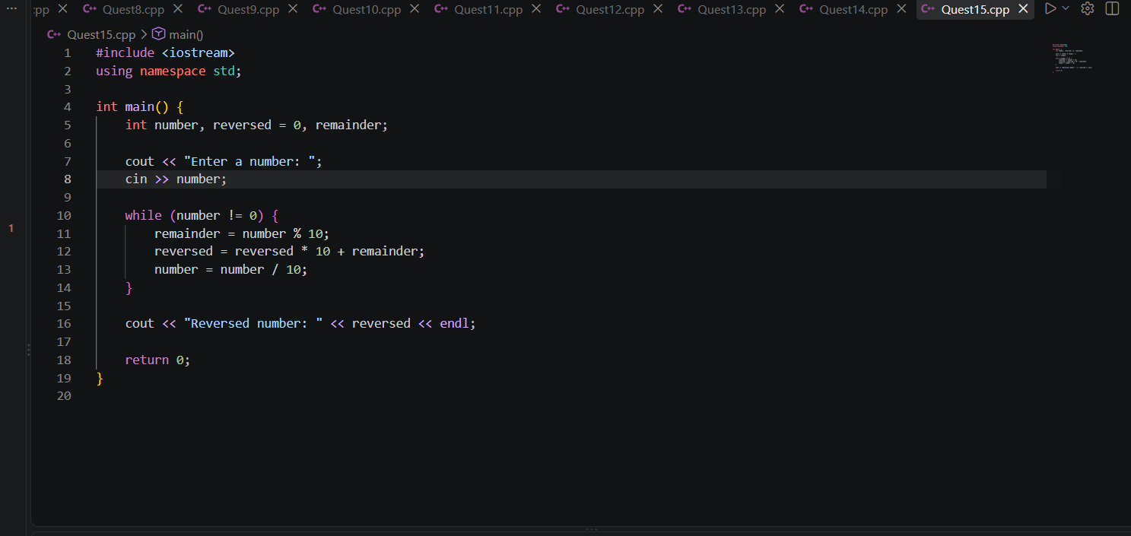
Output:
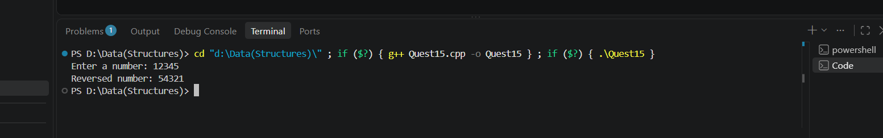

Lab Exercises 1.6
Task 1:
Write a recursive function to compute factorial of a number.
Program:
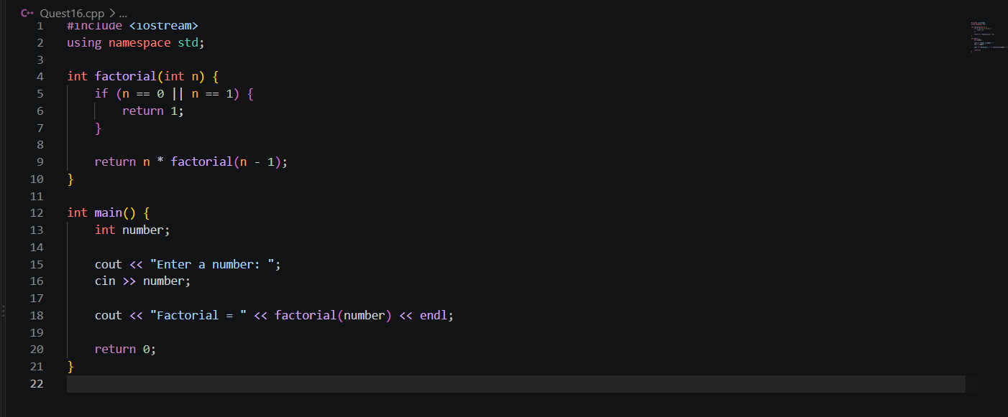
Output:
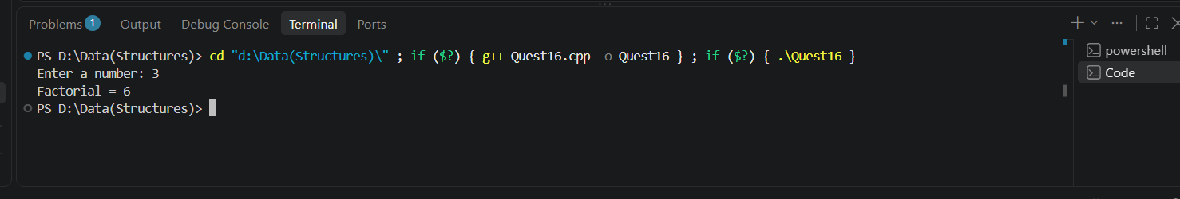
Task 2:
Write a function isPrime(int n) returning bool, and use it to print all primes between 1–100.
Program:
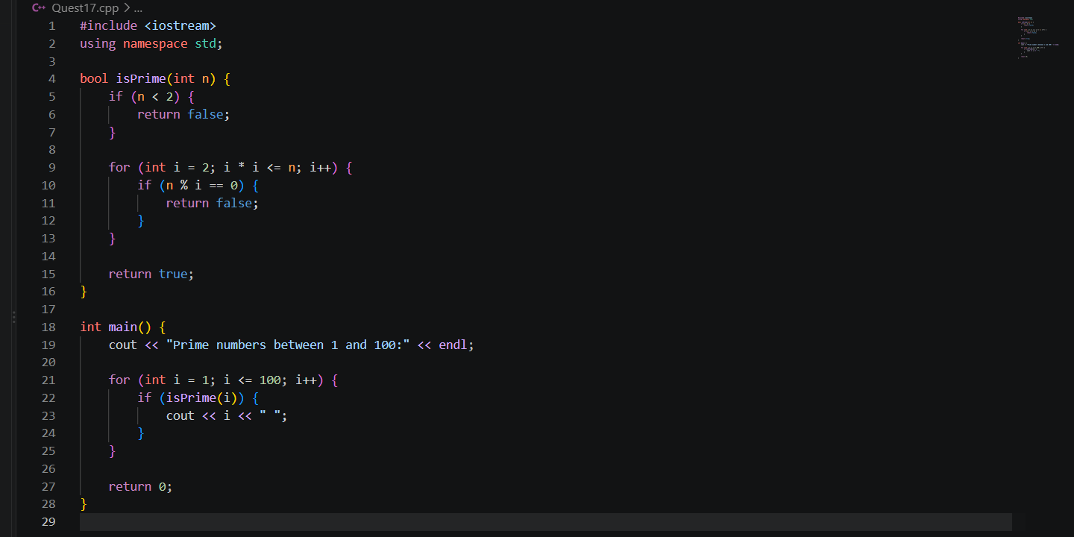
Output:
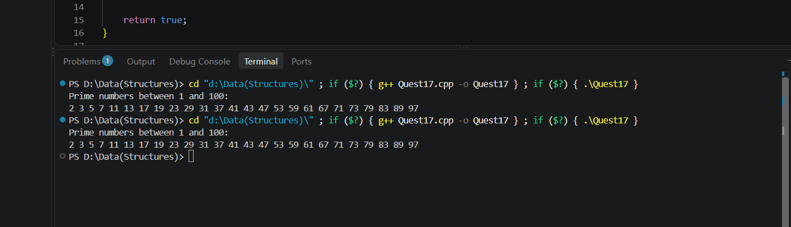
Task 3:
Write an overloaded area() function for a circle (1 param), rectangle (2 params), and triangle (2
params, different formula) — think about how you'd disambiguate.
Program:
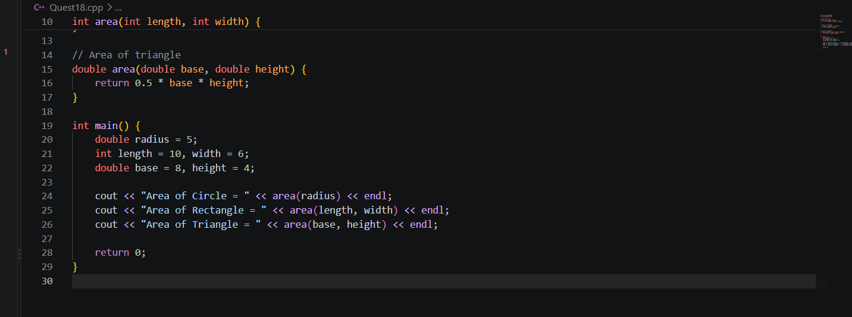
Output:
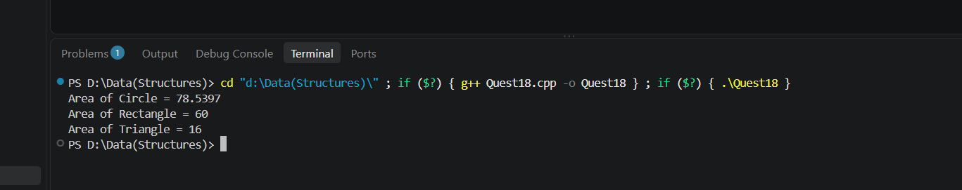
Task 4:
Write a function with a default argument, e.g., void greet(string name = "Guest").
Program:
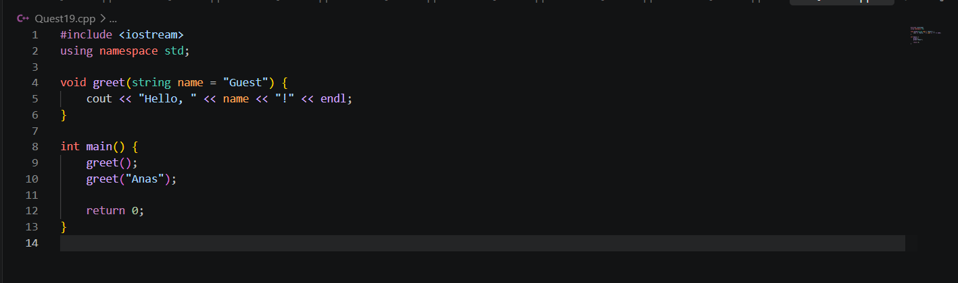
Output:
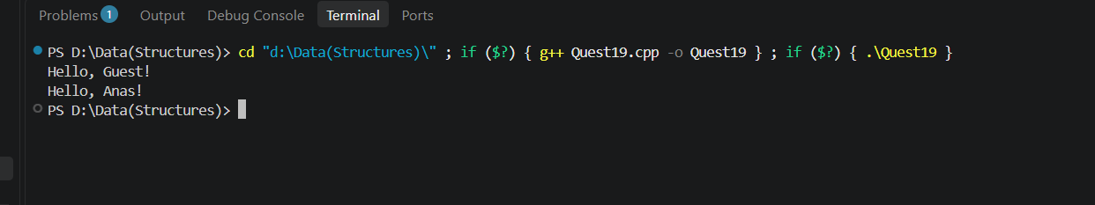

Lab Exercises 1.7
Task 1:
Implement linear search on an array.
Program:
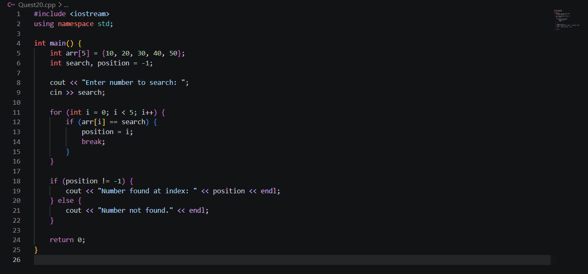
Output:
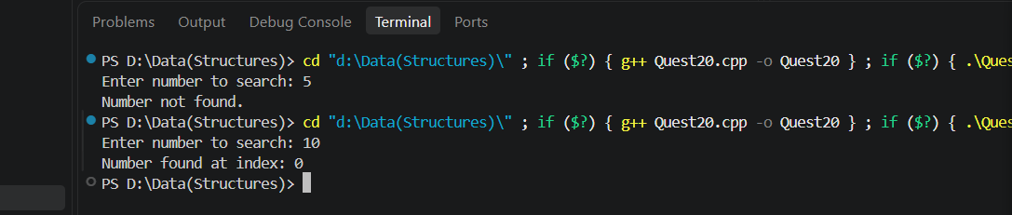
Task 2:
Implement bubble sort on an array of integers.
Program:
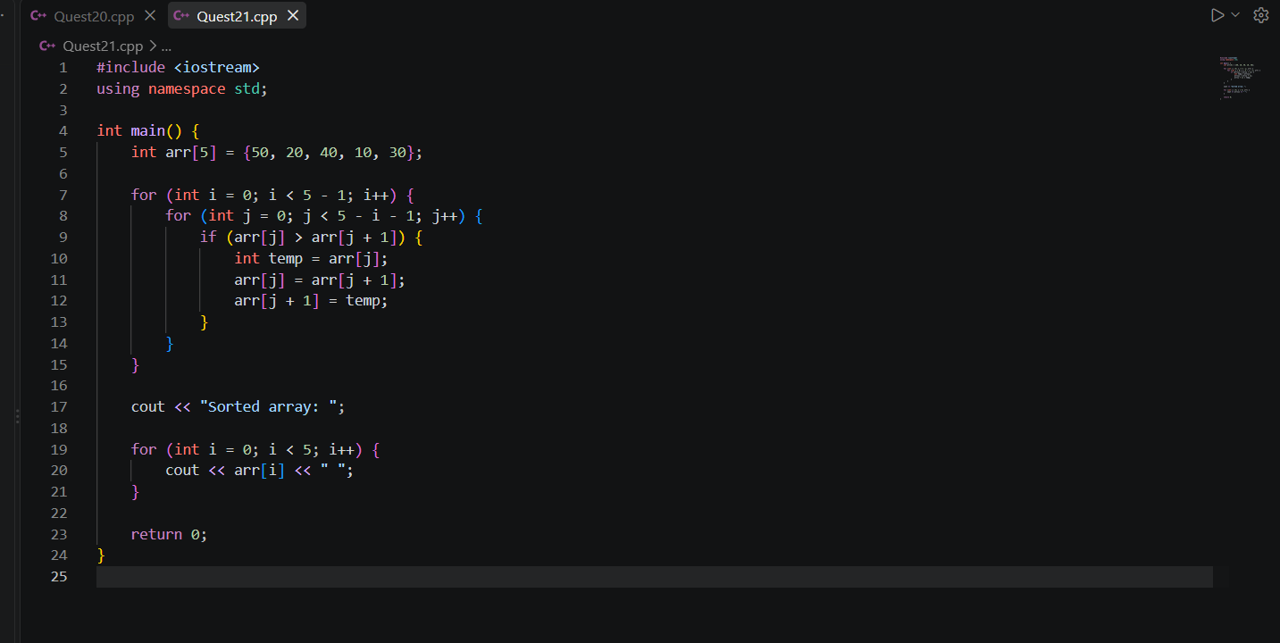
Output:
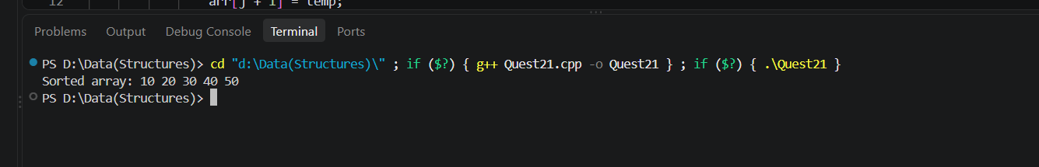

Task 3:
Write a program to find the transpose of a matrix.

Program:
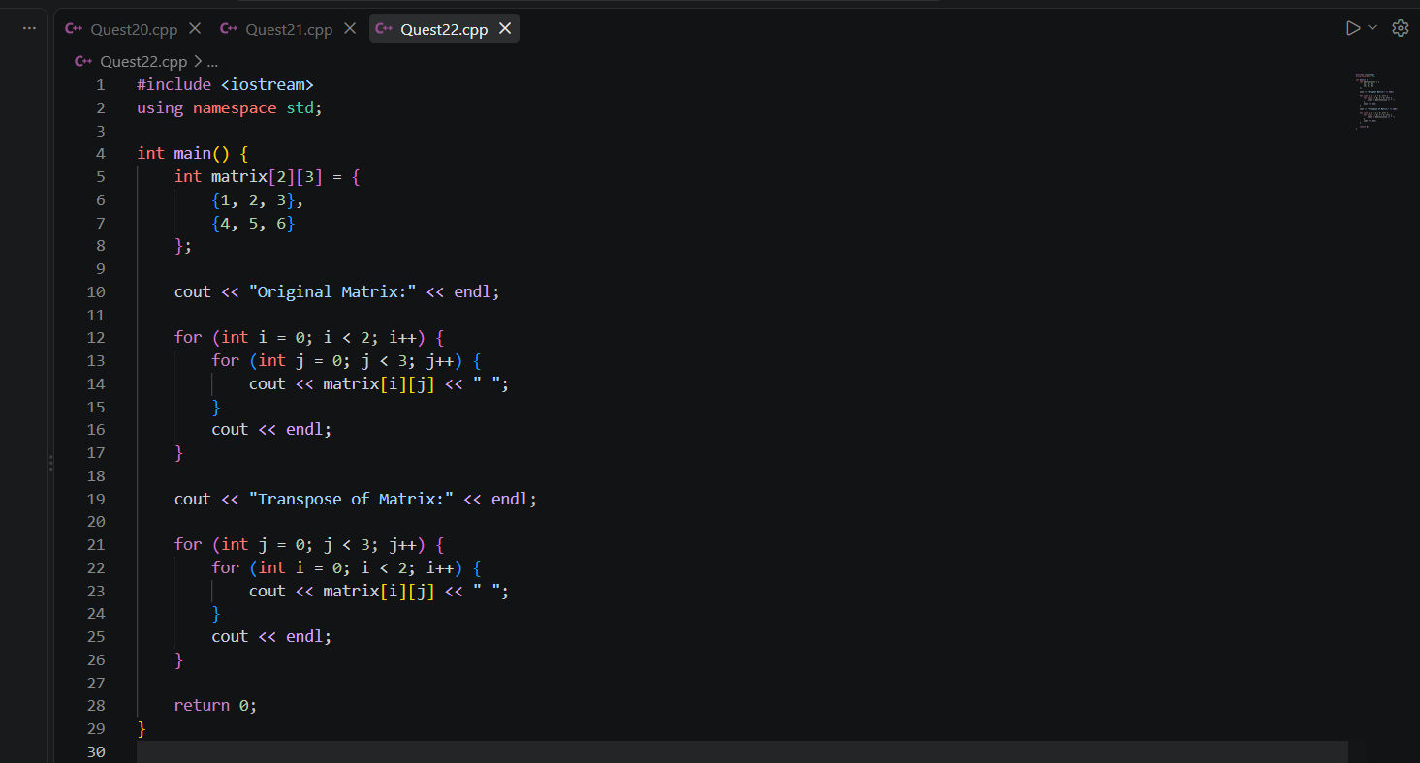
Output:
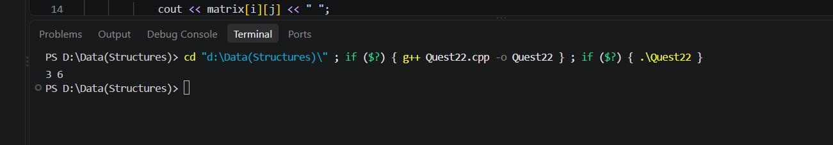
Task 4:
Reverse an array in place (without using a second array).

Program:
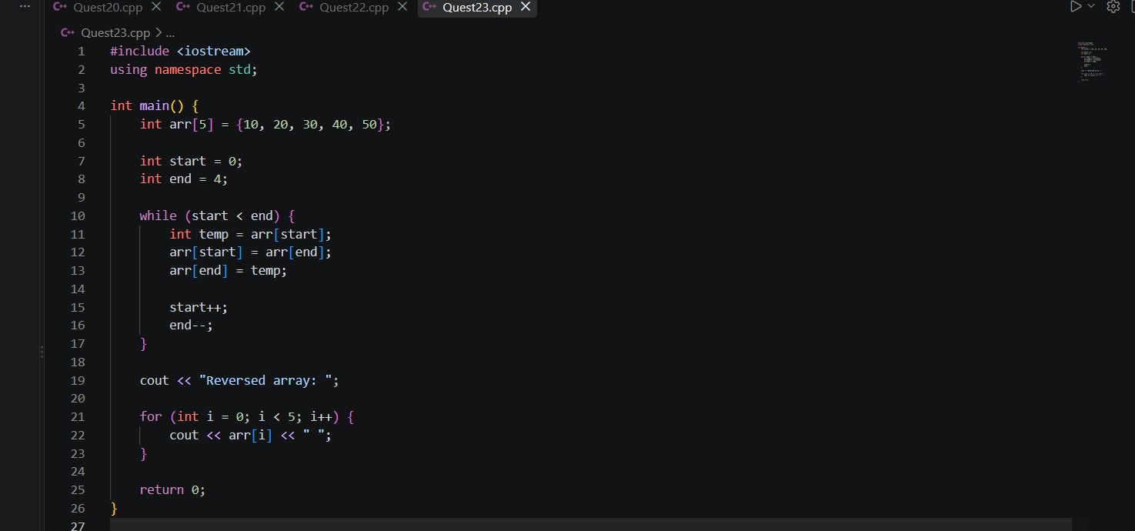
Output:
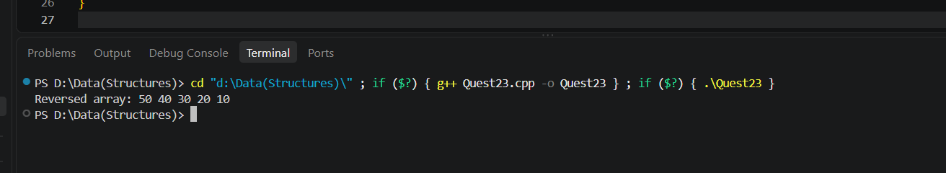

Lab Exercises 1.8
Task 1,2,3, 4:
Count vowels and consonants in a given string.
Write a program to count the number of words in a sentence.
Implement your own strlen() and strrev() using a C-style char array.
Find and replace a substring within a string.
Program:
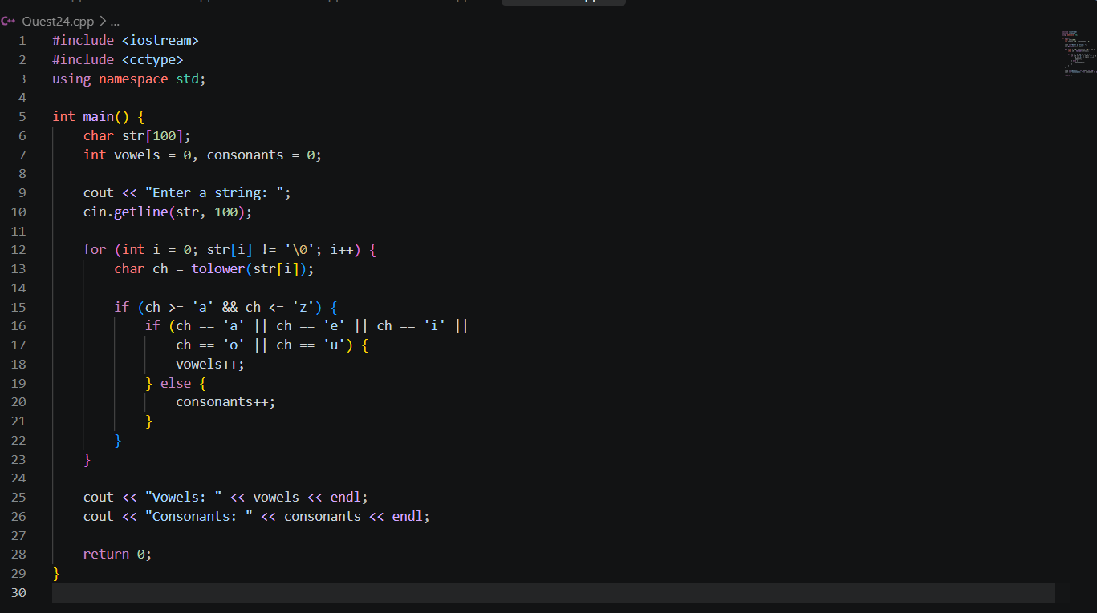
Output:
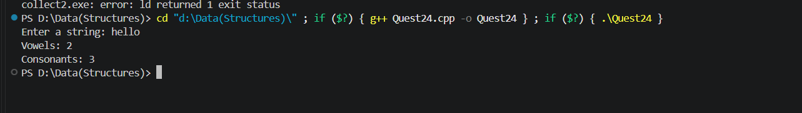

Program:
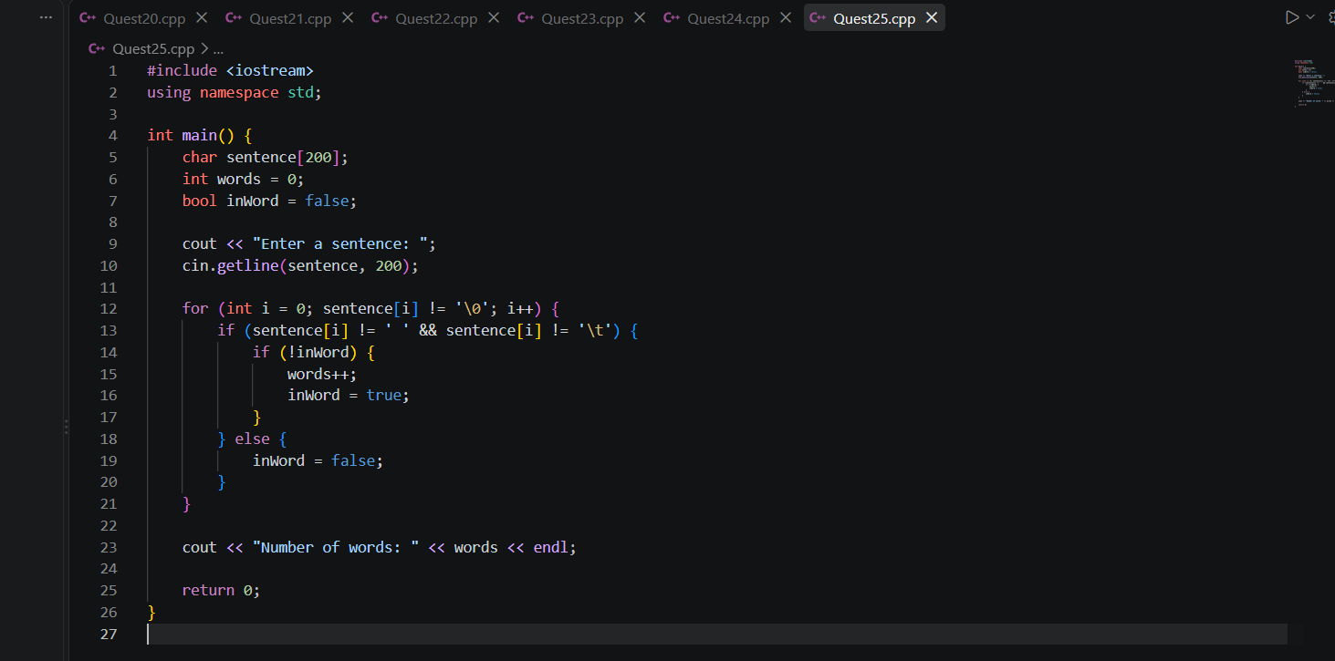
Output:
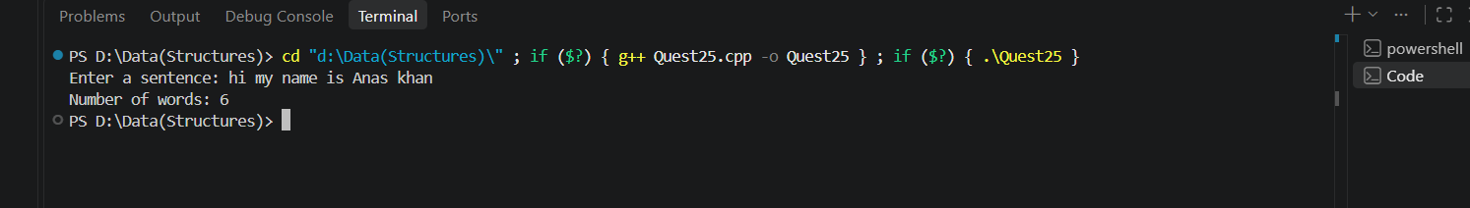

Program:
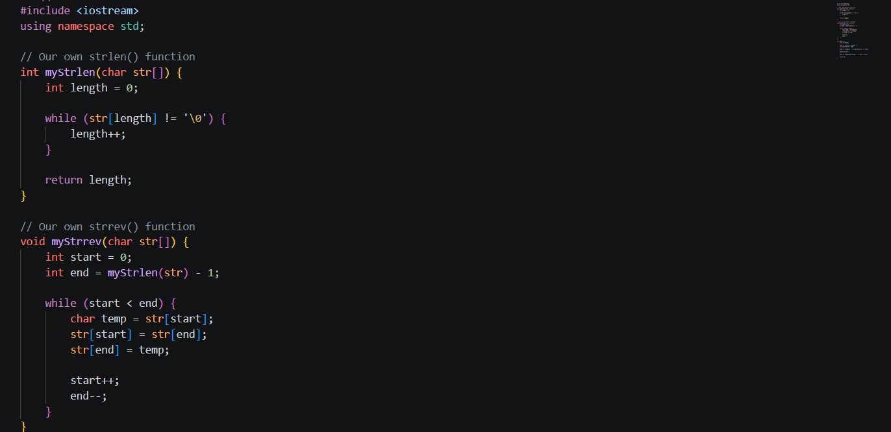
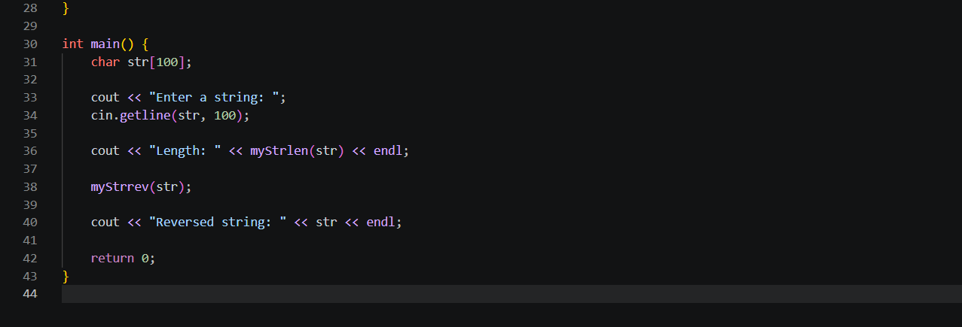
Output:
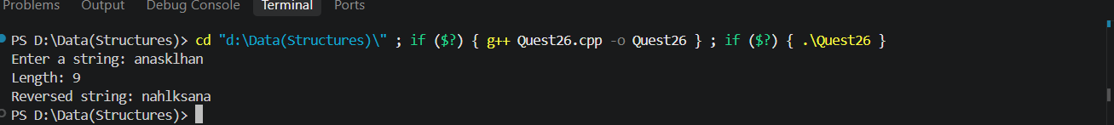

Lab Exercises 1.9
Task 1:
Write a function that uses a pointer parameter to double the value of a variable.
Program:
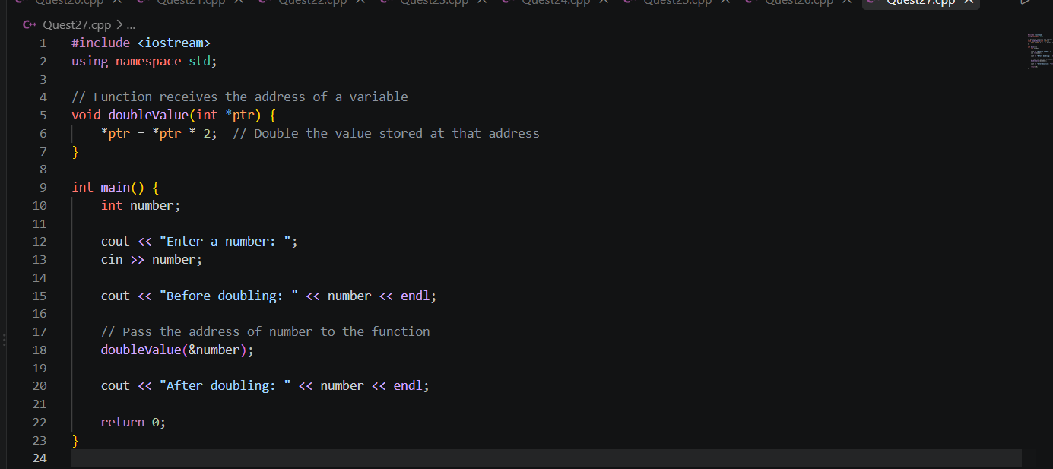
Output:
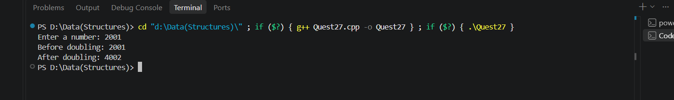
Task 2:
Demonstrate the difference between a pointer and a reference with code comments explaining each line.

Program:
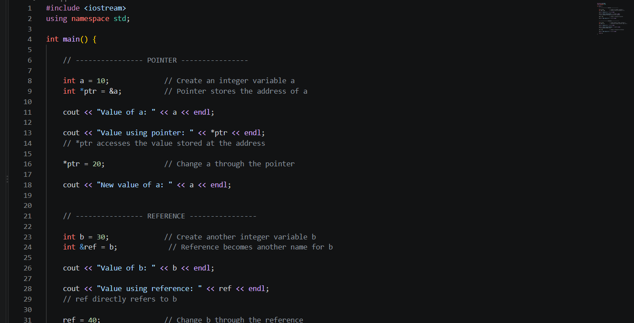
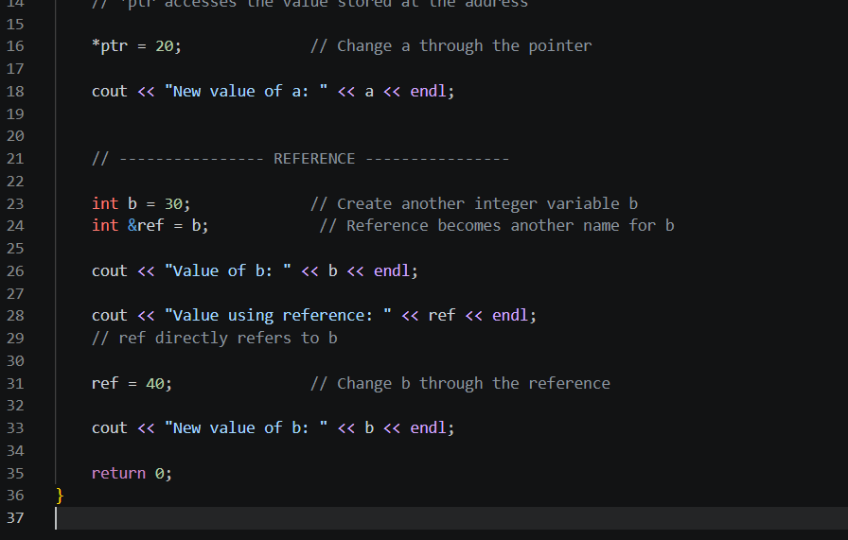

Output:
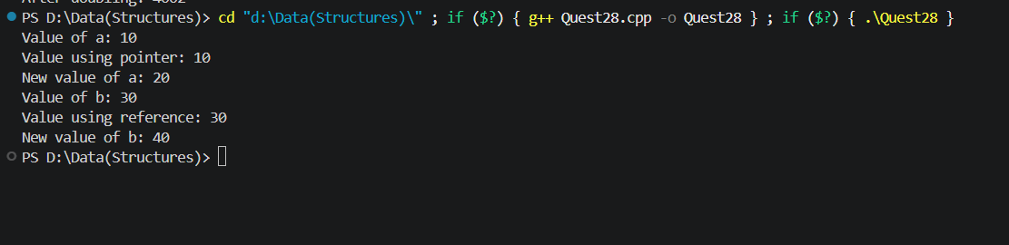
Task 3:
Create a dynamic 2D array using pointers, fill it, and free the memory correctly.
Program:
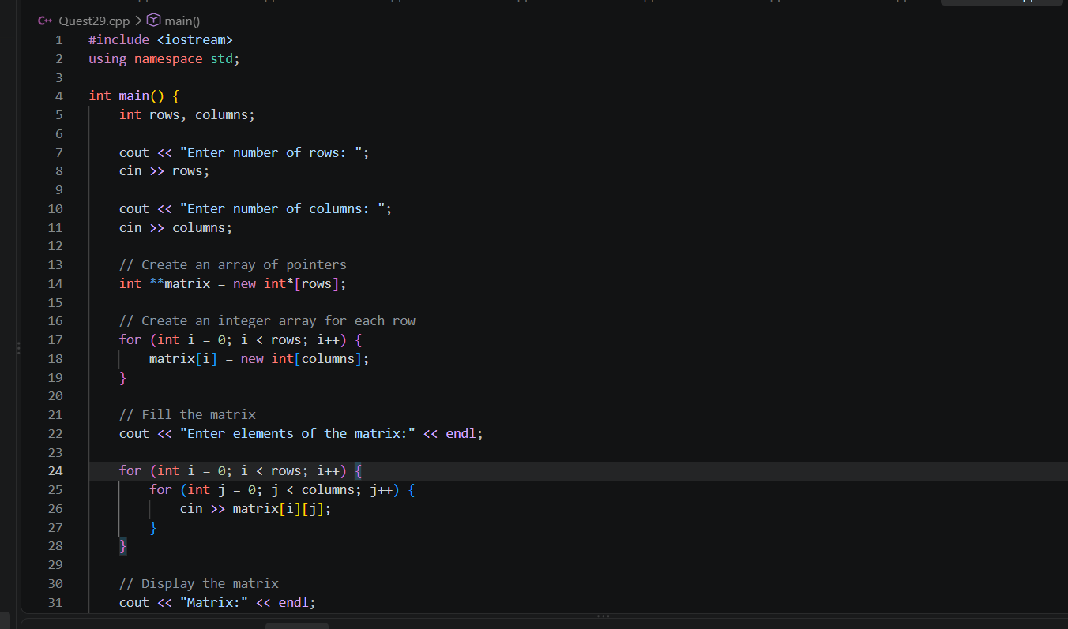
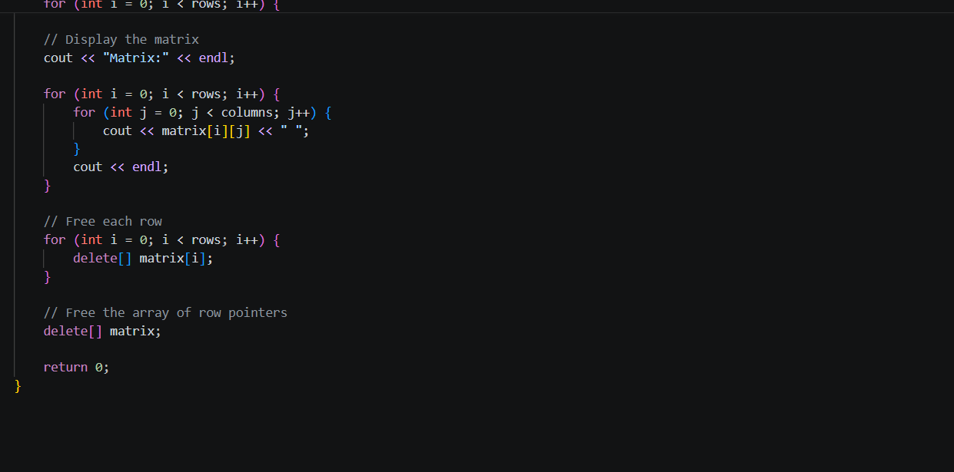
Output:
